ŠD Keka organizira:

Keka Cup
Odprto Državno prvenstvo Slovenije v windsurfingu: Razredi: Raceboard,Kona in RS;X
25-27.Maj 2018
Portorož – Slovenija
REGATNA NAVODILA – SAILING INSTRUCTIONS
1. PRAVILA
- 1.1. Regata bo potekala po pravilih, kot so definirana 1.1. v Jadralnih regatnih pravilih.
- 1.2. Pravilniki Jadralne zveze Slovenije bodo veljali 1.2. samo za slovenske jadrnice.
- 1.3. Veljala bodo pravila razreda Raceboard
- 1.4. Veljala bodo Jadralna pravila o opremi. 1.4.
- 1.5. Kazen za kršitev pravil razreda je lahko manjša od 1.5. diskvalifikacije. To spremeni pravilo 64.
- 1.6. Če so med jeziki pomenske razlike, bo odločilno 1.6. angleško besedilo.
- OBVESTILA TEKMOVALCEM 2. Obvestila tekmovalcem bodo objavljena na uradni oglasni deski, ki bo postavljena pred regatno pisarno v ŠD Keka.
- SPREMEMBE REGATNIH NAVODIL 3.
RULES
The race will be governed by the rules as defined in The Racing Rules of Sailing. Prescriptions of Slovenian Sailing Federation will apply only for Slovenian boats.
Raceboard class International class rules will apply. The Equipment Rules of Sailing will apply. Penalty for violation of the Class Rules may be less than disqualification. This changes Rule 64.
If there is a conflict between languages the English text will take precedence.
NOTICES TO COMPETITORS
Notices to competitors will be posted on the official notice board located in front of the Race Office in ŠD Keka.
CHANGES TO SAILING INSTRUCTIONS
Vse spremembe regatnih navodil bodo objavljene pred 09:30 uro dneva, ko začno veljati, razen sprememb v razporedu plovov, ki bodo objavljene dan prej, preden začnejo veljati, do 20:00. effect.
4. SIGNALI NA OBALI 4.
- 4.1. Signali na obali bodo izobešeni na zastavnem 4.1. jamboru Centra vodnih športov
- 4.2. Kadar je zastava kodeks izobešena na kopnem, se 4.2. ‘1 minuta’ v regatnem signalu Kodeks zamenja z ‘ne manj kot 30 minut’.
5. RAZPORED PLOVOV 5. 5.1. Datum Ura Opis Št. plovov 5.1.
SIGNALS MADE ASHORE
Signals made ashore will be displayed on the flag pole located in Center vodnih športov. When flag AP is displayed ashore, ‘1 minute’ is replaced with ‘not less than 30 minutes’ in the race signal AP
SCHEDULE OF RACES Date Time Description No. of races
26.05. 10:30 Skippers meeting –Sestanek krmarjev
12:00 Racing 4, - 4 plovi
18:00 Party and dinner-zabava in večerja
27.05. 11:00 Racing 4-4 plovi
17:00 Podelitev
- Any change to the sailing instructions will be posted before 09:30 on the day it will take effect, except that any change to the schedule of races will be posted by 20:00 on the day before it will take

- ZASTAVA RAZREDA Zastava razreda bo črka R
6. CLASS FLAG Class flag will be Leter “R”class insignia.
- REGATNA POLJA Na prilogi A je prikazana lokacija regatnih polj.
7. RACING AREAS
Attachment A shows the location of the regatta harbour and racing areas.
- PROGA
.8.1. V primeru postavitve le ene oznake vrat, morajo jadrnice le to pustiti levo.
8. THE COURSE
.8.1. If only one gate mark is set, boats shall leave the single mark to port.

9. OZNAKE
- 9.1. Oznake 1 in 2 bodo oranžne boji.
- 9.2. Nova oznaka, v skladu z navodilom 11.1, bo rumena boja.
- 9.3. Štartni oznaki bosta signalno plovilo regatnega odbora na desni in plovilo regatnega odbora ali rumena boja na levi strani.
- 9.4. Ciljni oznaki bosta signalno plovilo regatnega odbora na desni in ploviko regatnega odbora na levi strani.
- 9.5. Plovilo regatnega odbora, ki signalizira spremembo stranice proge, je oznaka skladna navodilu 11.2.
9. MARKS
- 9.1. Marks 1and 2 will be orange buoys.
- 9.2. New mark, as provided in instruction 11.1, will be yellow buoy.
- 9.3. The starting marks will be the race committee signal vessel at the starboard end a race committee vessel or yellow l buoy at the port end.
- 9.4. The finishing marks will be the race committee signal vessel at the starboard end and race committee boat at the port end.
- 9.5. A race committee vessel signalling a change of a leg of the course is a mark as provided in instruction 11.2.

10. ŠTART
- 10.1. Štartna linija bo med drogovoma z oranžnima zastavama na štartnih oznakah. V primeru, da plovilo regatnega odbora na levi ne bo na mestu, bo drog zamenjan s tekmovalno stranjo leve štartne oznake.
- 10.2. Ploviko, ki ne štarta v roku 4 minut po štartnem signalu, bo brez zaslišanja dobila točke, kot da ni štartala (DNS). S tem se spremenita RRS A4 in A5.
10. THE START
10.1. The starting line will be between staffs displaying orange flags on the starting marks. If port end mark vessel is not on position, it will be replaced with the course side of the port-end starting mark.
10.2. A boat starting later than 4 minutes after her starting signal will be scored Did Not Start without a hearing. This changes RRS A4 and A5.
11.CILJ
Ciljna linija bo med oranžno bojo na desni ciljni oznaki in plovilom regatnega odbora na leve ciljne oznake.
11. THE FINISH
The finishing line will be between orange mark at the starboard end and the race commette boat of the port-end fi.
12. PREDPISANI IN PREDVIDENI ČASI
12.1. Predpisani in predvideni časi so, kot sledi:
Predpisani čas 40 minut Če v predpisanem času za oznako 1 nobena jadrnica ni šla mimo oznake 1, bo plov razveljavljen. Odstopanje od predvidenih časov ne more biti osnova za nadomestilo. [NP].
12.2. Jadrnice, ki ne končajo 10 minut za tem, ko prva jadrnica prejadra progo in konča, brez zaslišanja dobijo točke za ‘Ni končala regate’ (DNF). S tem so spremenjena RRS 35, A4 in A5.
12.Time limits and target times
12.1. Time limits and target times are as follows:
Limit 40 minutes If no boat has passed Mark 1 within the Mark 1 time limit, the race will be abandoned. Failure to meet the target time will not be grounds for redress. [NP]
12.2. Boats failing to finish within 10 minutes after the first boat sailed the course and finishes, will be
Predpisani čas za 1. oznako 15 minut
Mark 1
Target
time limit 15 minutes
13. PROTESTI IN ZAHTEVKI ZA NADOMESTILO
- 13.1. Protestni obrazci so na voljo v regatni pisarni. Proteste, zahtevke za nadomestilo ali ponovitev zaslišanja je potrebno oddati v ustreznem času za oddajo protestov.
- 13.2. Čas za oddajo protestov je 60 minut po prihodu zadnje jadrnice na cilj zadnjega plova v dnevu ali po signalu regatnega odbora, da je tekmovanje za tisti dan zaključeno, kar je kasneje.
- 13.3. Obvestila bodo objavljena ne kasneje kot 30 minutah po izteku časa za oddajo protestov, da bodo tekmovalci obveščeni o zaslišanjih v katerih so sami zainteresirane stranke ali pa navedeni kot priče. Zaslišanja bodo potekala v regatni pisarni z začetkom ob uri, ki bo navedena na oglasni deski.
- 13.4. Obvestila o protestih s strani regatnega odbora ali žirije bodo objavljena, da bodo jadrnice obveščene po RRS 61.1(b).
- 13.5. Sklepi mednarodne žirije so dokončni po RSS 70.5
13. PROTESTS AND REQUESTS FOR REDRESS
13.1. Protest forms are available at the Race Office. Protests and requests for redress or reopening shall be delivered there within the appropriate time limit.
13.2. The protest time limit is 60 minutes after the last boat has finished the last race of the day or the race committee signals no more racing today, whichever is later.
13.3. Notices will be posted no later than 30 minutes after the protest time limit to inform competitors of hearings in which they are parties or named as witnesses. Hearings will be held in the race office, beginning at the time posted on the notice board.
13.4. Notices of protests by the race committee or jury will be posted to inform boats under RRS 61.1(b).
13.5. Decisions of the international jury will be final as provided in RRS 70.5.

14. TOČKOVANJE
- 14.1. Regata bo veljavna, če bodo izpeljani vsaj trije plovi.
- 14.2. (a) Če bo izpeljanih manj kot pet plovov, bodo jadrničine točke za serijo enake vsoti njenih točk za vse plove. (b) Če bo izpeljanih pet ali več plovov, bodo jadrničine točke za serijo enake vsoti njenih točk za plove minus točke za njen najslabši plov.
14. SCORING
. 14.1. Three races are required to be completed to constitute a series.
. 14.2. (a) When fewer than five races have been completed, a boat's series score will be the total of her race scores. (b) When five or more races have been completed, a boat’s series score will be the total of her race scores excluding her worst score. scored Did Not Finish without a hearing. This changes RRS 35, A4 and A5.
15. SAFETY REGULATION
A boat that retires from a race shall notify the race committee as soon as possible. [DP]
16. PRIZES
Prizes will be awarded to: - first three in Klas Raceboard and first three in klas Kona One,. -
16. NAGRADE
Nagrajene bodo: - prvi trije v klasi Raceboard in prvi trije v klasi Kona One
17.ODKLONITEV ODGOVORNOSTI .
Tekmovalci v celoti sodelujejo na lastno odgovornost. Glej pravilo 4, Odločitev za tekmovanje. Organizator ne prevzema nobene odgovornosti za materialno škodo ali telesne poškodbe ali smrt, ki bi nastali v kakršnikoli zvezi z regato, bodisi pred regato, med njo ali po regati. [NP]
17.DISCLAIMER OF LIABILITY
Competitors participate in the regatta entirely at their own risk. See rule 4, Decision to Race. The Organizing Authority will not accept any liability for material damage or personal injury or death sustained in conjunction with or prior to, during, or after the regatta. [NP]
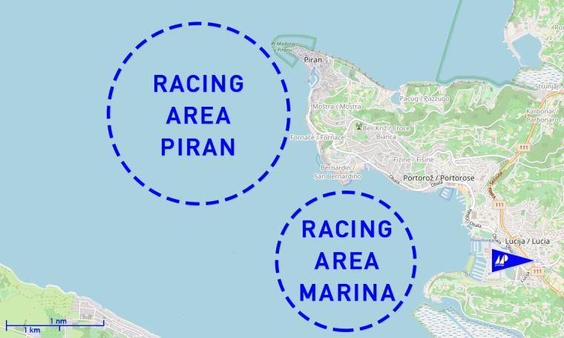
ŠD Keka: Obala 7 Portorož
www.keka.si
Info: 040633999

